**The Riddler**

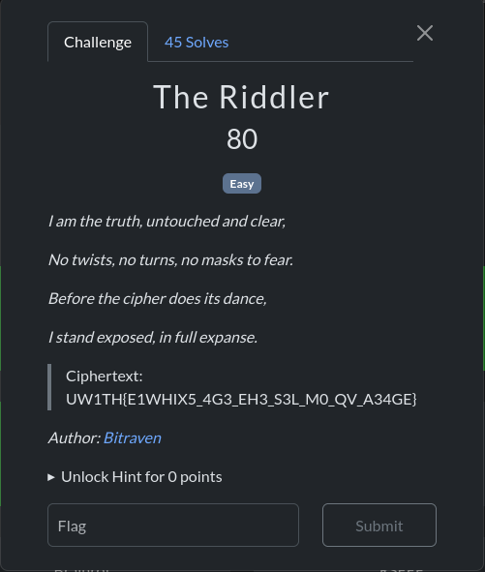

We have the ciphertext to decrypt is : **UW1TH{E1WHIX5_4G3_EH3_S3L_M0_QV_A34GE}**In this puzzle the riddle itself tells you that nothing has been “**twisted**” – it is the truth in its plain (i.e. un‐“ciphered”) form. In other words, the answer to the riddle (the “**encryption key**”) is

Encryption key = “**plaintext**”

We can then go to <https://www.dcode.fr/> and choose **Vigenere Cipher** and then input our text and encryption key

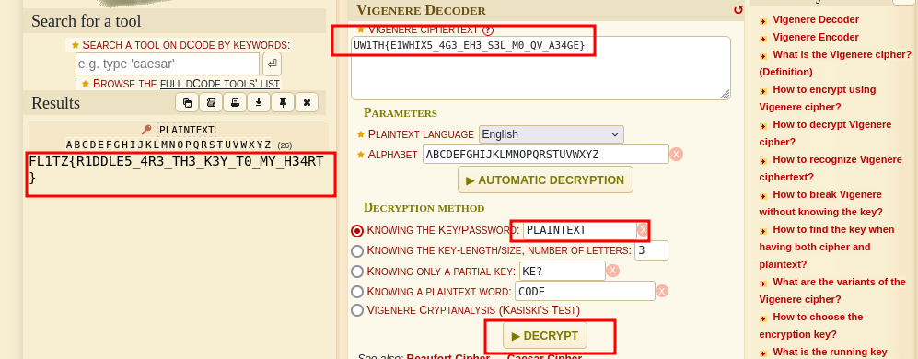

And that’s our flag ☺ ….